Kubernetes Basics
- What is Kubernetes?
- How does Kubernetes handle container orchestration?
- What are the main components of the Kubernetes architecture?
- What is the role of the Kubernetes Master Node?
- What is a Node in Kubernetes?
- What is a Pod in Kubernetes?
- What are namespaces in Kubernetes?
- How does Kubernetes differ from Docker Swarm?
- What is the Kubernetes API, and how does it work?
- How can you interact with the Kubernetes API using kubectl and client libraries?
- What is the role of API groups in Kubernetes?
- What is the difference between the Kubernetes API and CRDs?
- What is namespace in kubernetes?

What is Kubernetes?

Kubernetes is an open-source container orchestration platform designed to automate the deployment, scaling, and management of containerized applications. Originally developed by Google, it helps manage containerized applications across a cluster of machines.
Here are some key features and concepts of Kubernetes:
- Containers: Kubernetes works with containerized applications, which are lightweight, portable units that include everything needed to run an application (code, runtime, libraries, and dependencies).
- Pods: The smallest deployable units in Kubernetes, pods can contain one or more containers that share storage, network, and configuration.
- Nodes: These are the machines (physical or virtual) that make up the Kubernetes cluster. Each node runs a container runtime, a kubelet (agent that ensures containers are running), and a kube-proxy (handles network routing).
- Clusters: A group of nodes working together to run containerized applications. Clusters are managed by the Kubernetes control plane.
- Deployments: Manage the deployment and scaling of pods. They ensure that a specified number of pod replicas are running at any given time.
- Services: Define a logical set of pods and a policy to access them. Services allow communication between different parts of an application and expose them to external traffic.
- Namespaces: Provide a way to divide cluster resources between multiple users or applications, helping to organize and manage resources efficiently.
- ConfigMaps and Secrets: Manage configuration data and sensitive information (like passwords) for applications running in the cluster.
- Volumes: Provide persistent storage that outlives the life of a pod. This is useful for applications that need to store data beyond the life of individual containers.
- Ingress: Manages external access to services in a cluster, typically HTTP and HTTPS traffic.
Kubernetes is widely used in cloud environments and on-premises data centers to manage containerized applications efficiently, providing high availability, scalability, and disaster recovery.
//////////////////////////////////////////////////////////////////////////////////////////////////////////////////////

How does Kubernetes handle container orchestration?
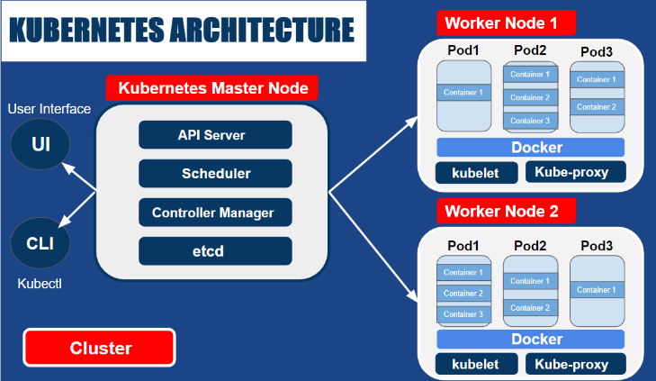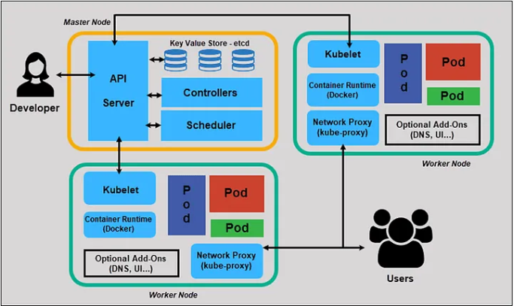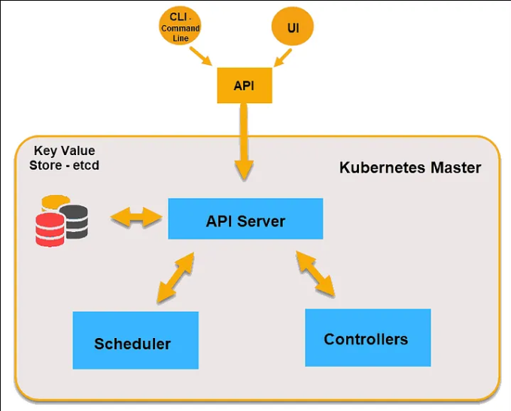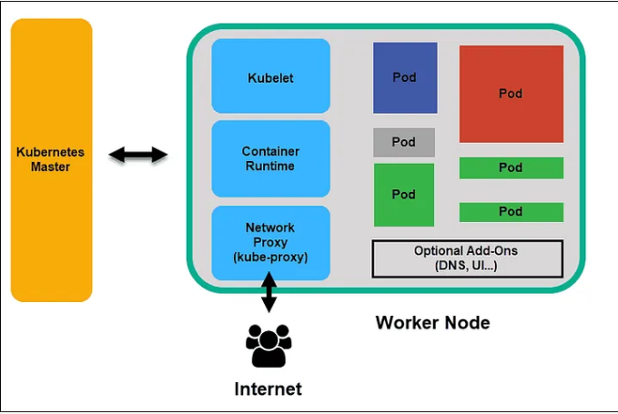
Kubernetes handles container orchestration through several core components and processes that work together to ensure containers are deployed, scaled, and managed efficiently. Here's how Kubernetes manages container orchestration:
- Control Plane: The control plane is responsible for managing the overall state of the cluster. It includes several key components:
  - API Server: The API server exposes the Kubernetes API, allowing users and other components to interact with the cluster.
  - Controller Manager: Monitors the state of the cluster and makes or requests necessary changes to maintain the desired state (e.g., starting new pods or scaling applications).
  - Scheduler: Decides which nodes should run newly created pods based on resource availability and other constraints.
  - etcd: A key-value store that maintains the cluster’s state and configuration data.
- Nodes: Nodes are the worker machines in the cluster where containers run. Each node includes:
  - Kubelet: An agent that ensures containers are running as expected. It communicates with the API server and manages the containers on the node.
  - Container Runtime: Software responsible for running containers (e.g., Docker, containerd).
  - Kube-Proxy: Handles network routing and load balancing for services running on the node.
- Pods: The smallest deployable unit in Kubernetes, a pod can contain one or more containers. Pods share storage and network resources, making it easier to manage related containers as a single unit.
- Deployments: Manage the lifecycle of pods by ensuring that a specified number of pod replicas are running. Deployments handle rolling updates, rollbacks, and scaling operations.
- Services: Define how to access pods, abstracting away the details of pod IP addresses and enabling stable networking. Services can load-balance traffic to multiple pods and provide consistent access to applications.
- Replication Controllers: Ensure that a specified number of pod replicas are running at any time. They are replaced by Deployments in newer versions of Kubernetes but still serve as a fundamental concept in orchestrating pods.
- Horizontal Pod Autoscaling: Automatically scales the number of pod replicas based on observed CPU utilization or other custom metrics.
- Job and CronJob: Manage the execution of tasks. Jobs ensure that a specified number of pods successfully complete a task, while CronJobs schedule tasks to run periodically.
- Namespaces: Provide a way to organize and manage resources within the cluster, allowing for isolation and resource allocation among different users or teams.
- ConfigMaps and Secrets: Manage configuration data and sensitive information, providing a way to inject this data into containers without hardcoding it into application code.
Through these components, Kubernetes ensures that containers are efficiently deployed, scaled, and managed, allowing for high availability and fault tolerance in containerized applications.
//////////////////////////////////////////////////////////////////////////////////////////////////////////////////////

What are the main components of the Kubernetes architecture?
The Kubernetes architecture consists of several main components that work together to manage containerized applications effectively. Here’s a breakdown of these key components:

Control Plane Components
- API Server (kube-apiserver):
  - Acts as the front end for the Kubernetes control plane.
  - Exposes the Kubernetes API, which is used by other components and external clients to interact with the cluster.
  - Handles API requests, validates them, and updates the etcd database.
- Controller Manager (kube-controller-manager):
  - Manages various controllers that handle routine tasks in the cluster, such as scaling, replication, and handling node failures.
  - Examples include the ReplicaSet Controller, Job Controller, and Namespace Controller.
- Scheduler (kube-scheduler):
  - Responsible for scheduling pods onto nodes based on resource availability and other constraints.
  - Considers factors like CPU, memory, and node affinity when making scheduling decisions.
- etcd:
  - A distributed key-value store used for storing cluster state and configuration data.
  - Acts as the source of truth for the cluster’s configuration and status.
- Cloud Controller Manager (cloud-controller-manager):
  - Interfaces with cloud providers to manage resources specific to a cloud environment, such as load balancers and storage volumes.
  - Ensures that Kubernetes can manage resources in a cloud provider's environment.

Node Components
- Kubelet:
  - An agent running on each node that ensures containers are running in the pods as specified by the control plane.
  - Communicates with the API server and manages the container runtime on the node.
- Container Runtime:
  - The software responsible for running containers (e.g., Docker, containerd).
  - Handles the creation, management, and execution of containers.
- Kube-Proxy:
  - Manages network routing and load balancing for services running on the node.
  - Ensures that network traffic is properly routed to the appropriate pods.

Cluster Components
- Pods:
  - The smallest deployable units that can contain one or more containers.
  - Share storage and network resources, and are managed by higher-level controllers.
- Services:
  - Define how to access and communicate with pods.
  - Provide a stable IP address and DNS name for accessing pods and load balance traffic among them.
- Volumes:
  - Provide persistent storage for containers that outlives the life of individual pods.
  - Enable data to be retained and shared between containers.
- Namespaces:
  - Provide a way to divide cluster resources between multiple users or teams.
  - Help in organizing and isolating resources within the cluster.
- ConfigMaps and Secrets:
  - ConfigMaps store non-sensitive configuration data.
  - Secrets store sensitive information such as passwords and tokens, ensuring secure data management.
- Deployments:
  - Manage the deployment and scaling of pods.
  - Handle rolling updates and rollbacks to ensure applications are always running the desired version.
- Jobs and CronJobs:
  - Jobs manage the execution of tasks that need to complete successfully.
  - CronJobs schedule tasks to run at specified intervals, similar to cron jobs in Unix-like systems.
These components work together to provide a robust and scalable environment for deploying and managing containerized applications.
//////////////////////////////////////////////////////////////////////////////////////////////////////////////////////

What is the role of the Kubernetes Master Node?
The Kubernetes Master Node (often simply called the Master) plays a central role in managing and controlling the Kubernetes cluster. It is responsible for overseeing the cluster's state, making scheduling decisions, and maintaining the overall health of the cluster. Here are the key roles and responsibilities of the Kubernetes Master Node:

Key Responsibilities of the Kubernetes Master Node
- Cluster Management:
  - API Server: Exposes the Kubernetes API, allowing users and other components to interact with the cluster. It serves as the gateway to the cluster’s control plane.
  - Controller Manager: Runs various controllers that ensure the cluster is in the desired state. It monitors the cluster and takes corrective actions, such as scaling up pods or rescheduling them if necessary.
  - Scheduler: Assigns newly created pods to nodes based on resource availability and other constraints. It ensures that pods are distributed across nodes in a way that meets resource and policy requirements.
  - etcd: Acts as the distributed key-value store that holds all the cluster's state data and configuration. It is the source of truth for the cluster and provides persistent storage for critical information.
- Cluster State Management:
  - The Master Node keeps track of the desired and current state of the cluster. It uses the information stored in etcd to maintain the cluster’s desired state and make necessary updates to achieve it.
- Scheduling and Resource Allocation:
  - The Scheduler makes decisions about where to place pods based on resource requirements, node availability, and other constraints. It ensures efficient resource utilization across the cluster.
- Deployment and Scaling:
  - The Master Node handles the deployment of applications by managing Deployments, ReplicaSets, and other controllers. It ensures that the desired number of replicas are running and can perform rolling updates and rollbacks.
- Health Monitoring and Maintenance:
  - The Master Node continuously monitors the health of various components within the cluster. It takes corrective actions if components fail or if the cluster state deviates from the desired configuration.
- API and User Interaction:
  - The API Server on the Master Node serves as the primary interface for administrators and users to interact with the cluster. It handles requests to create, update, and delete resources.

Components on the Master Node
- kube-apiserver: The central API server that processes and validates API requests.
- kube-controller-manager: Manages controllers that regulate the state of the cluster.
- kube-scheduler: Responsible for scheduling pods onto nodes.
- etcd: The distributed database that stores cluster configuration and state.
- cloud-controller-manager (if used): Manages cloud-specific resources and integrates with cloud providers.
Overall, the Kubernetes Master Node is critical for the orchestration and management of the Kubernetes cluster, ensuring that it operates smoothly and efficiently.
//////////////////////////////////////////////////////////////////////////////////////////////////////////////////////

How does Kubernetes differ from Docker Swarm?
Kubernetes and Docker Swarm are both container orchestration tools, but they have different architectures, features, and use cases. Here’s a comparison of the two:

1. Architecture and Complexity
- Kubernetes:
  - Complexity: More complex and feature-rich, with a steeper learning curve.
  - Architecture: Has a well-defined control plane consisting of components like API Server, Controller Manager, Scheduler, and etcd. It uses a distributed system architecture and provides robust capabilities for scaling, networking, and storage.
  - Features: Offers advanced features like horizontal scaling, rolling updates, self-healing, service discovery, and network policies.
- Docker Swarm:
  - Complexity: Simpler and easier to set up compared to Kubernetes.
  - Architecture: Built directly into Docker, using a simpler architecture with Manager Nodes and Worker Nodes. Swarm mode integrates with Docker CLI and Docker Compose, providing a more straightforward experience.
  - Features: Provides basic features for clustering, load balancing, and service discovery, but lacks some of the advanced capabilities of Kubernetes.

2. Deployment and Configuration
- Kubernetes:
  - Deployment: Typically requires more configuration and setup, involving multiple components and a Kubernetes API server.
  - Configuration Files: Uses YAML files for defining deployments, services, and other resources. Configuration can be extensive due to its flexibility.
- Docker Swarm:
  - Deployment: Easier to deploy and manage, especially for users already familiar with Docker.
  - Configuration Files: Uses Docker Compose files to define services, which can be simpler and more familiar to Docker users.

3. Scaling and Load Balancing
- Kubernetes:
  - Scaling: Supports both manual and automatic scaling of pods and deployments based on resource utilization and custom metrics.
  - Load Balancing: Provides built-in load balancing through Services and Ingress Controllers, with advanced options for traffic management.
- Docker Swarm:
  - Scaling: Supports manual scaling of services, with some basic auto-scaling features available through external tools.
  - Load Balancing: Includes built-in load balancing for services, but with less flexibility and fewer features compared to Kubernetes.

4. Networking
- Kubernetes:
  - Networking: Implements a complex networking model with support for multiple network plugins and advanced networking features like Network Policies and service meshes.
  - Service Discovery: Provides built-in service discovery and DNS resolution for services within the cluster.
- Docker Swarm:
  - Networking: Uses Docker’s overlay network for container communication across nodes, with a simpler networking model compared to Kubernetes.
  - Service Discovery: Provides basic service discovery through DNS and load balancing within the Swarm.

5. Storage
- Kubernetes:
  - Storage: Offers a rich set of options for persistent storage, including Persistent Volumes (PVs) and Persistent Volume Claims (PVCs), with support for various storage backends and dynamic provisioning.
- Docker Swarm:
  - Storage: Provides basic support for persistent storage, with less flexibility compared to Kubernetes. Typically relies on Docker volumes and external solutions.

6. Ecosystem and Community
- Kubernetes:
  - Ecosystem: Has a large and active community, with a vast ecosystem of tools, plugins, and integrations. Widely adopted in both cloud and on-premises environments.
- Docker Swarm:
  - Ecosystem: Smaller ecosystem compared to Kubernetes, with less community-driven development and fewer third-party integrations.

Summary
- Kubernetes is a powerful and feature-rich orchestration platform that provides advanced capabilities for managing containerized applications at scale. It is well-suited for complex, large-scale environments and offers extensive customization and flexibility.
- Docker Swarm is a simpler and more integrated solution that is easier to set up and use for smaller or less complex environments. It is a good choice for users who need basic container orchestration with minimal configuration and are already familiar with Docker.
Your choice between Kubernetes and Docker Swarm will depend on your specific needs, environment, and familiarity with the tools.
//////////////////////////////////////////////////////////////////////////////////////////////////////////////////////

What is the Kubernetes API, and how does it work?
The Kubernetes API is a central component of the Kubernetes control plane that allows users and components to interact with the Kubernetes cluster. It serves as the primary interface for communication between various parts of the cluster and provides a way to manage and manipulate cluster resources.

Key Aspects of the Kubernetes API
- API Server (kube-apiserver):
  - The API server is the core component that exposes the Kubernetes API.
  - It handles all API requests, processes them, validates the data, and updates the cluster state accordingly.
  - It acts as a gateway to the cluster, ensuring that all interactions are channeled through a single point.
- Resources and Endpoints:
  - The Kubernetes API organizes cluster resources into objects like Pods, Services, Deployments, and more.
  - Each resource type has a corresponding API endpoint (e.g., /api/v1/pods for Pods) that can be accessed via HTTP requests.
  - Resources are identified by their API groups, versions, and kinds. For example, a Deployment might be accessed at /apis/apps/v1/deployments.
- CRUD Operations:
  - The API supports Create, Read, Update, and Delete (CRUD) operations on resources.
  - Create: Use POST requests to create new resources.
  - Read: Use GET requests to retrieve resource information.
  - Update: Use PUT or PATCH requests to modify existing resources.
  - Delete: Use DELETE requests to remove resources.
- Authentication and Authorization:
  - The API server enforces authentication to ensure that only authorized users and components can access the API.
  - Kubernetes supports various authentication mechanisms, such as certificates, bearer tokens, and OAuth.
  - Authorization determines what actions authenticated users can perform on resources, managed through roles and role bindings (RBAC).
- Admission Control:
  - Admission controllers are plugins that intercept API requests before they are persisted in etcd.
  - They can modify or reject requests based on policies or constraints (e.g., resource quotas, security policies).
- API Versioning:
  - The API is versioned to ensure backward compatibility and support for evolving features.
  - Kubernetes APIs follow a versioning scheme that includes major, minor, and patch versions (e.g., /api/v1, /apis/apps/v1).
- Custom Resources:
  - Kubernetes allows users to define Custom Resource Definitions (CRDs) to extend the API with custom resource types.
  - Custom resources enable users to model application-specific objects and manage them through the Kubernetes API.
- API Aggregation Layer:
  - The API aggregation layer allows Kubernetes to extend its API with additional APIs provided by external services or controllers.
  - This enables the integration of third-party components and custom extensions into the Kubernetes API.

How It Works
- Client Interaction:
  - Users and applications interact with the Kubernetes API using tools like kubectl, client libraries, or custom applications.
  - Requests are typically made over HTTPS to the API server.
- Request Processing:
  - The API server processes incoming requests, performs validation, and updates the cluster state as necessary.
  - It interacts with etcd to store and retrieve resource data.
- Event Notification:
  - The API server can notify clients of changes to resources through watch mechanisms.
  - Clients can watch for changes to specific resources or groups of resources and receive real-time updates.
- Controller Interaction:
  - Controllers within the cluster use the API to monitor and manage resources.
  - They perform tasks like scaling, updating, and managing the state of applications based on the desired state defined by users.
Overall, the Kubernetes API is the foundation of the Kubernetes system, providing a consistent and flexible way to interact with and manage the cluster. It centralizes control and management, allowing users and components to efficiently handle containerized applications and services.
//////////////////////////////////////////////////////////////////////////////////////////////////////////////////////

How can you interact with the Kubernetes API using kubectl and client libraries?
Interacting with the Kubernetes API can be done through various methods, primarily using kubectl and client libraries. Here’s how you can use these tools to interact with the Kubernetes API:

Using kubectl
kubectl is the command-line tool for interacting with the Kubernetes API. It allows you to manage Kubernetes resources and perform various administrative tasks. Here are some common ways to use kubectl:
- Basic Commands:
  - Get Resources: Retrieve information about resources in the cluster.
kubectl get pods
kubectl get services
  - Describe Resources: Get detailed information about a specific resource.
kubectl describe pod <pod-name>
  - Create Resources: Create new resources using YAML or JSON configuration files.
kubectl create -f <file>.yaml
  - Apply Changes: Apply changes to resources defined in configuration files. This command can be used to create or update resources.
kubectl apply -f <file>.yaml
  - Delete Resources: Remove resources from the cluster.
kubectl delete pod <pod-name>
- Filtering and Customizing Output:
  - Output Formats: Customize the output format to JSON, YAML, or custom columns.
kubectl get pods -o yaml
kubectl get pods -o json
kubectl get pods -o custom-columns=NAME:.metadata.name,STATUS:.status.phase
  - Label Selectors: Filter resources based on labels.
kubectl get pods -l app=my-app
- Accessing Logs and Executing Commands:
  - View Logs: Retrieve logs from a specific pod.
kubectl logs <pod-name>
  - Execute Commands: Run commands inside a container in a pod.
kubectl exec -it <pod-name> -- /bin/bash
- Interacting with the API:
  - Direct API Requests: You can use kubectl to interact with the API directly by specifying the API endpoint.
kubectl proxy
curl http://localhost:8001/api/v1/namespaces/default/pods

Using Client Libraries
Client libraries provide programmatic access to the Kubernetes API from various programming languages. They allow you to build applications and automation scripts that interact with the Kubernetes cluster. Here are some popular client libraries and examples of how to use them:
- Go Client (client-go):
  - The official Go client library for Kubernetes.
  - Example usage:
package main

import (
"context"
"fmt"
"k8s.io/client-go/kubernetes"
"k8s.io/client-go/tools/clientcmd"
)

func main() {
config, err := clientcmd.BuildConfigFromFlags("", "/path/to/kubeconfig")
if err != nil {
panic(err)
}
clientset, err := kubernetes.NewForConfig(config)
if err != nil {
panic(err)
}

pods, err := clientset.CoreV1().Pods("default").List(context.TODO(), metav1.ListOptions{})
if err != nil {
panic(err)
}

for _, pod := range pods.Items {
fmt.Println(pod.Name)
}
}
- Python Client (kubernetes-python):
  - A Python client library for Kubernetes.
  - Example usage:
from kubernetes import client, config

def main():
config.load_kube_config() # Load kubeconfig from default location
v1 = client.CoreV1Api()
pods = v1.list_namespaced_pod(namespace='default')

for pod in pods.items:
print(pod.metadata.name)

if __name__ == '__main__':
main()
- JavaScript Client (kubernetes-client):
  - A JavaScript client for Kubernetes, often used with Node.js.
  - Example usage:
const k8s = require('@kubernetes/client-node');

async function main() {
const k8sApi = k8s.KubeConfig.fromFile('/path/to/kubeconfig');
const k8sClient = k8s.KubeConfig.loadFromFile('/path/to/kubeconfig');
const coreApi = k8sClient.makeApiClient(k8s.CoreV1Api);

try {
const res = await coreApi.listNamespacedPod('default');
res.body.items.forEach(pod => console.log(pod.metadata.name));
} catch (error) {
console.error(error);
}
}

main();
- Java Client (kubernetes-client-java):
  - A Java client library for interacting with Kubernetes.
  - Example usage:
import io.kubernetes.client.openapi.ApiClient;
import io.kubernetes.client.openapi.Configuration;
import io.kubernetes.client.openapi.models.V1PodList;
import io.kubernetes.client.openapi.api.CoreV1Api;
import io.kubernetes.client.openapi.auth.Configuration;

public class Main {
public static void main(String[] args) {
ApiClient client = Configuration.getDefaultApiClient();
CoreV1Api api = new CoreV1Api(client);

try {
V1PodList list = api.listNamespacedPod("default", null, null, null, null, null, null, null, null, null);
list.getItems().forEach(pod -> System.out.println(pod.getMetadata().getName()));
} catch (Exception e) {
e.printStackTrace();
}
}
}

Summary
- kubectl: A powerful command-line tool for interacting with the Kubernetes API, suitable for manual management and debugging.
- Client Libraries: Provide programmatic access to the Kubernetes API, enabling automation, custom applications, and integration with other systems.
Both methods enable you to manage and interact with Kubernetes resources, offering different levels of abstraction and control based on your needs and preferences.
//////////////////////////////////////////////////////////////////////////////////////////////////////////////////////

What is the role of API groups in Kubernetes?
In Kubernetes, API groups play a crucial role in organizing and versioning the API resources. They help manage the complexity of the API and facilitate extension and evolution over time. Here’s a breakdown of the role and benefits of API groups:

1. Organizing Resources
- Resource Categorization: API groups categorize related resources into logical groups. This helps in organizing resources that serve similar purposes or belong to the same functional area. For example, the apps group includes resources like Deployments and ReplicaSets, while the core group includes fundamental resources like Pods and Services.
- Separation of Concerns: By grouping related resources, Kubernetes provides a structured way to manage and interact with them. This separation helps in understanding and managing the API surface more effectively.

2. Versioning and Evolution
- Versioning: API groups allow Kubernetes to manage the evolution of the API over time. Each API group can have multiple versions (e.g., v1, v2beta1), which enables the introduction of new features or changes without breaking existing clients.
- Backward Compatibility: Different versions within an API group can coexist, allowing users to upgrade to newer versions at their own pace. This ensures backward compatibility and smooth transitions between versions.

3. Extensibility
- Custom Resources: API groups facilitate the addition of Custom Resource Definitions (CRDs), enabling users to extend Kubernetes with custom resource types. Custom resources are integrated into the Kubernetes API under user-defined API groups.
- API Aggregation Layer: Kubernetes supports extending the API through the API Aggregation Layer, which allows external services to expose their APIs in the Kubernetes API server. This layer uses API groups to manage and integrate these external APIs seamlessly.

4. Accessing Resources
- Resource Paths: Resources are accessed through specific API group paths. For example:
  - The core group resources (such as Pods) are accessed at /api/v1.
  - Resources in the apps group (such as Deployments) are accessed at /apis/apps/v1.
  - Custom resources might be accessed through a custom API group path like /apis/mygroup.example.com/v1.
- Discovery and Documentation: API groups help in discovering and documenting available resources and their versions. The Kubernetes API server provides API documentation and discovery endpoints (like /apis and /apis/{group}) to list available groups and resources.

5. Management and Operations
- API Server Management: The API server is designed to handle requests to different API groups and versions. It routes requests to the appropriate API handlers based on the group and version specified in the request.
- Client Libraries and Tools: API groups help client libraries and tools (such as kubectl) interact with the Kubernetes API by providing a structured way to handle different resource types and versions.

Example of API Groups
- Core Group (v1): Contains essential Kubernetes resources.
  - Path: /api/v1
  - Resources: Pods, Services, ConfigMaps, Secrets
- Apps Group: Manages application-related resources.
  - Path: /apis/apps/v1
  - Resources: Deployments, ReplicaSets, StatefulSets
- Batch Group: Handles batch processing resources.
  - Path: /apis/batch/v1
  - Resources: Jobs, CronJobs
- Networking Group: Deals with network-related resources.
  - Path: /apis/networking.k8s.io/v1
  - Resources: NetworkPolicies, Ingress
- Custom Groups: User-defined groups for custom resources.
  - Path: /apis/mygroup.example.com/v1
  - Resources: CustomResourceDefinitions (CRDs)
In summary, API groups in Kubernetes help in organizing, versioning, and extending the API. They ensure that the API remains manageable and extensible while providing a structured approach to interacting with and managing cluster resources.
//////////////////////////////////////////////////////////////////////////////////////////////////////////////////////

What is the difference between the Kubernetes API and CRDs?
The Kubernetes API and Custom Resource Definitions (CRDs) are related but serve different purposes in Kubernetes. Here’s a breakdown of their differences and roles:

Kubernetes API
- Purpose:
  - The Kubernetes API provides the core interface for interacting with and managing the Kubernetes cluster. It exposes the standard set of Kubernetes resources, operations, and functionalities.
- Standard Resources:
  - The API includes a set of built-in resources that are fundamental to Kubernetes, such as Pods, Services, Deployments, ReplicaSets, and Nodes. These resources are defined by Kubernetes itself and are part of the core and well-known API groups.
- API Groups:
  - The API is organized into different groups and versions (e.g., core/v1, apps/v1, batch/v1) that manage various types of resources and functionalities. This grouping helps in organizing resources and managing their evolution over time.
- Versioning:
  - The Kubernetes API supports versioning to manage changes and upgrades without breaking backward compatibility. Different versions of the API groups coexist, allowing users to transition smoothly between versions.
- Interaction:
  - Users and tools interact with the Kubernetes API using HTTP requests to various endpoints (e.g., /api/v1/pods). The API server processes these requests, validates them, and updates the cluster state accordingly.

Custom Resource Definitions (CRDs)
- Purpose:
  - CRDs extend the Kubernetes API by allowing users to define and manage custom resource types that are not part of the standard Kubernetes resources. They enable the creation of new resource types tailored to specific use cases or applications.
- Custom Resources:
  - CRDs define custom resources that integrate into the Kubernetes API, allowing users to interact with them just like standard Kubernetes resources. For example, you can define a Database resource with a CRD and manage it using kubectl commands.
- API Group and Version:
  - When you create a CRD, you specify an API group and version for your custom resource. This allows your custom resources to be accessed through a dedicated API path (e.g., /apis/mygroup.example.com/v1/databases).
- Schema and Validation:
  - CRDs allow you to define the schema and validation rules for custom resources. You can specify required fields, data types, and validation constraints to ensure that custom resources adhere to the expected format.
- Controller Integration:
  - CRDs are often used in conjunction with custom controllers or operators. A custom controller watches for changes to custom resources and performs specific actions based on their state, enabling advanced automation and management.
- Discovery and Management:
  - Once a CRD is created, Kubernetes API clients (like kubectl) can interact with custom resources as if they were native resources. The Kubernetes API server handles requests for custom resources based on the definitions provided by the CRD.

Key Differences
- Built-In vs. Custom: The Kubernetes API provides standard, built-in resources that are fundamental to cluster operation, while CRDs allow users to define and manage their own custom resources.
- Standardization vs. Extensibility: The Kubernetes API standardizes interactions with core resources, whereas CRDs offer extensibility by enabling the creation of custom resources tailored to specific needs.
- Schema and Validation: The Kubernetes API enforces schemas and validation for standard resources. CRDs allow users to define schemas and validation rules for custom resources.

Example
- Kubernetes API: Managing a Deployment resource using the core Kubernetes API.
kubectl get deployments
kubectl apply -f deployment.yaml
- Custom Resource Definition (CRD): Defining and managing a custom resource (e.g., Database).
  - CRD Definition (in YAML):
apiVersion: apiextensions.k8s.io/v1
kind: CustomResourceDefinition
metadata:
name: databases.mygroup.example.com
spec:
group: mygroup.example.com
names:
kind: Database
listKind: DatabaseList
plural: databases
singular: database
scope: Namespaced
versions:
- name: v1
served: true
storage: true
schema:
openAPIV3Schema:
type: object
properties:
spec:
type: object
properties:
databaseName:
type: string
  - Custom Resource Instance (in YAML):
apiVersion: mygroup.example.com/v1
kind: Database
metadata:
name: my-database
spec:
databaseName: my-db
In summary, the Kubernetes API is the built-in, core interface for managing standard Kubernetes resources, while CRDs extend this API by allowing users to define and manage custom resource types tailored to their specific requirements.
//////////////////////////////////////////////////////////////////////////////////////////////////////////////////////
In Kubernetes, a namespace is a way to logically divide and group resources within a Kubernetes cluster. It is used to provide scope for names of resources, ensuring that different teams, projects, or environments can use the same resource names without conflicts. Namespaces offer a mechanism for organizing and managing resources, especially in large clusters where multiple users or teams share the same cluster.

Key Points about Namespaces:
- Logical Partitioning: Namespaces provide logical separation, allowing resources such as pods, services, and deployments to be grouped under a specific context. Each namespace can have its own set of resources, configurations, and policies.
- Resource Isolation: Different namespaces are isolated from each other. Resources in one namespace cannot directly access resources in another unless explicitly allowed (via network policies or cross-namespace service access).
- Name Scoping: Resources within the same namespace must have unique names, but resources across namespaces can have the same name (e.g., two services named frontend can exist in different namespaces).
- Access Control: Namespaces can be used to apply role-based access control (RBAC), allowing administrators to assign different permissions to users or groups for specific namespaces.
- Resource Quotas and Limits: Namespaces enable the enforcement of resource limits and quotas, helping manage how much CPU, memory, or storage each namespace can consume.

Default Namespaces in Kubernetes:
- default: The default namespace where objects are created if no namespace is specified.
- kube-system: Used for Kubernetes system components (e.g., kube-dns, kube-proxy).
- kube-public: A namespace that is readable by all users; it is generally used for public-facing data.
- kube-node-lease: Used for managing node leases (heartbeat information between nodes and the control plane).

How to Create and Use a Namespace:
- Creating a Namespace: You can create a namespace using a YAML configuration file or the kubectl command:
Using kubectl:
kubectl create namespace dev
Using YAML:
apiVersion: v1
kind: Namespace
metadata:
name: dev
Then, apply the file:
bash
Copy code
kubectl apply -f namespace.yaml
- Deploying Resources in a Namespace: When creating resources such as Pods, Services, or Deployments, you can specify the target namespace using the --namespace flag or by including the namespace in your YAML file:
Using kubectl:
kubectl create deployment nginx --image=nginx --namespace=dev
In a YAML file:
apiVersion: apps/v1
kind: Deployment
metadata:
name: nginx-deployment
namespace: dev
spec:
replicas: 3
selector:
matchLabels:
app: nginx
template:
metadata:
labels:
app: nginx
spec:
containers:
- name: nginx
image: nginx
- Switching Between Namespaces: You can switch between namespaces when interacting with resources:
kubectl get pods --namespace=dev
To set a namespace as the default for your current kubectl session, use:
kubectl config set-context --current --namespace=dev

Use Cases for Namespaces:
- Multi-Tenancy: Multiple teams can share a single Kubernetes cluster by using namespaces to isolate their workloads and resources.
- Environment Separation: Namespaces can be used to separate different environments like development, staging, and production within the same cluster.
- Resource Quotas: Set resource limits on namespaces to ensure that no single environment or team consumes all cluster resources.

Limitations of Namespaces:
- Namespaces cannot span across multiple clusters.
- Namespaces are limited to certain resource types (e.g., Pods, Services, ConfigMaps). Some resources like nodes, storage classes, and persistent volumes are not namespaced.

Conclusion:
Namespaces in Kubernetes are a powerful feature that enables logical isolation, resource management, and efficient team collaboration within shared clusters. They help to organize workloads, enforce access controls, and manage resource consumption effectively.

